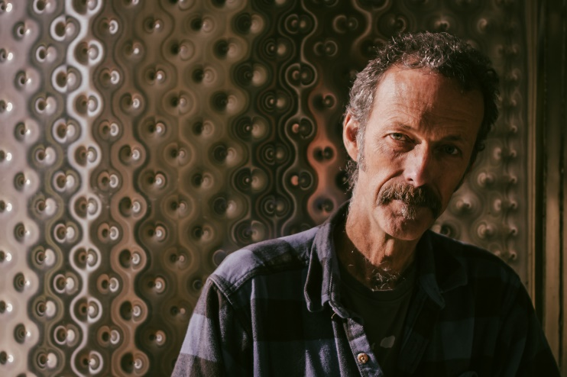
Fred Scherrer
Owner/ winemaker Fred Scherrer first made wine at home from the family vineyard as a teenager. This lead to technical training with a degree at U.C. Davis and then back to the "real world" to learn where, when, how, and importantly if to apply science to the art of winemaking. This real-world experience included some early days making wine in Alexander Valley and in Mendocino County. He returned to Sonoma County in 1988, making wine at Dehlinger for 10 years. During this time, Fred refined his original philosophy that "winemaking revolves around the vineyard".
“In 1991 while I was at Dehlinger, I began Scherrer Winery by making Zinfandel from vines my grandfather planted in 1912. During this time, it became obvious to me that Zinfandel, when not harvested over-ripe, shows a similar level of site expression as Pinot Noir. After becoming fully self-employed in 1998, production was gradually expanded to include Pinot Noir, Cabernet Sauvignon, Chardonnay, Syrah and Grenache. I make both single-vineyard wines and blends of sites that offer great components rather than complete, signatures of site, as well as multi-varietal and multi-vintage blends when it makes the best wine, such as our non-vintage Zinfandoodle.
Outside of harvest and bottling, I do most all of the cellar work myself. Following my father’s passing late 2020, I also work in the family vineyard where I grew up. Our annual production is currently about 3500 cases. Judi, my wife, has handled administrative and compliance for the winery since 2002, keeping me out of trouble with bureaucrats and making sure we are able to conform with the complex and changing direct shipping laws.”

